

**Next week in class 1 they will be:**

* Planning and writing information page about animals.
* Adding and subtracting using symbols
* Begin to make Dioramas.

**In Class 2:**

* Next week, year two will continue to look at how they can read, understand and complete word problems independently in Maths.
* In English, they will continue to learn the difference between formal, and informal letters.
* As they are planning a surprise, the rest of their topic will remain a little bit of a secret. The only thing they have said that I tell you, is that we will be planting and growing.

**In class 3 they will be:**

* For English and topic, they'll begin to find out about and discover the effects of deforestation in the rainforest. We will look at both sides of the argument and begin to use persuasive language to convince listeners and readers.
* In maths, Year 3 will be consolidating their knowledge of turns and angles whereas Year 4 will be finding the area of rectilinear shapes and completing symmetrical figures.
* We will be calculating the final count for the number of days each child has read and recorded their reading during June.  Who will have read the most?

**In class 4:**

* Next week Class Four will be focussing on Mayan Culture, and beliefs and how these differ from our own.
* They will also be continuing their focus on solving calculations using the four main operations.
* In art they shall be designing their own Mayan masks.



Wednesday 3rd July- Carn Brea sport event. (selected children only)

Thursday 4th July- Sports Day from 1.30pm

Monday 8th July- Yr4 -6 Football game at Tregadillett School 3.30pm Kick off.

Wednesday 10th July-Music Assembly 1.30pm- all welcome.

Friday 19th July- 10 Step

Tuesday 23rd July- Year 6 Leavers trip (After School)

24th July- Leavers and Celebration assembly

25th July-END OF TERM

Monday 12th August to Friday 16th August, from 08:30 to 14:30.-Launceston College Summer School

Wednesday 4th September- INSET DAY

Thursday 5th September- AUTUMN TERM BEGINS

28th June 2019



**Mr Ellis Office Hours**

Monday-PM

Tuesday- All Day

Thursday- All Day

Friday- PM



Year 4/5/6 team have been invited to play a match against Tregadillett on Monday 8th July at 3.30pm at Tregadillett School. Could parents of Yr4/5/6 players please inform Miss Hicks or Mr Griffith if your child would like to attend. We will be looking for parents to transport children to and from the event.



**Attendance**

**School year to date 97%**

This has increased by 1.8%



With the end of the school year approaching, we are reconciling our finances and have noticed a lot of outstanding payments for school meals, swimming and FunFit. There is over £400 outstanding in swimming payments from the last year, this is just over 2 weeks bus hire.

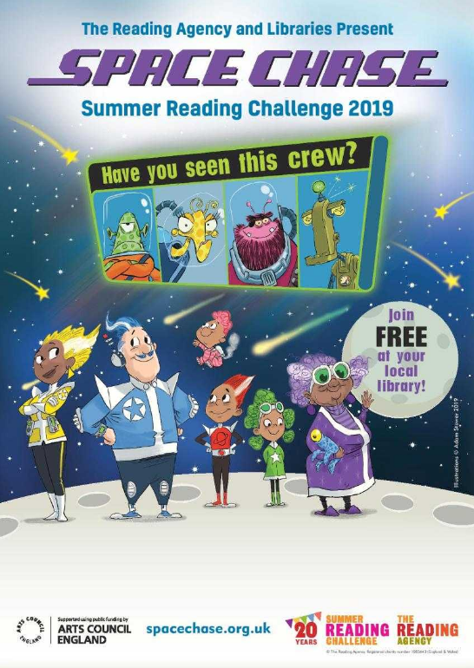



Our vacancy for a part time HLTA, to start with the team from September is now live. We will be accepting applications from experienced, skilled and established TA’s.

Please share with friends/family/anyone you may know who would be interested.

[Current Vacancies](http://www.aspireacademytrust.org/188/current-vacancies)



Thank you to my amazing team, taking children on school trips is not an easy task. Each trip was excellent and children returned brimming with excitement about their experiences.

If you haven’t already done so please look at your ESchools message regarding a recent case of Pinworm in the school

**Music**

This week has seen the choir out on 2 visits, 1 to the Hubbub at Wadebridge and the other joined by the Samba band performing at Tregadillett’s schools music festival.

A massive thank you to all the parent volunteers from choir and samba that we have had this week, without you, none of this would be possible. Yesterday I was so proud of the way Warbstow conducted themselves and the feedback I had from parents from Tregadillett and staff was how amazing they all were.

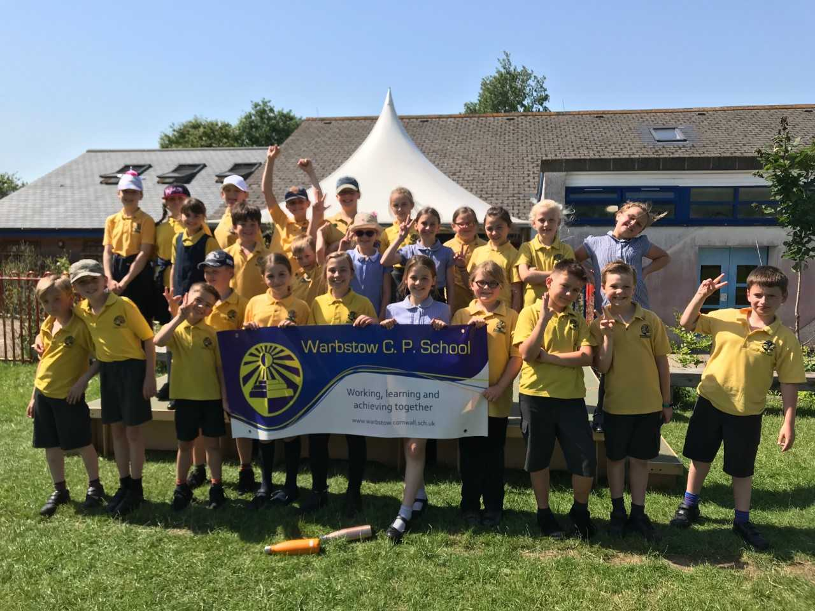 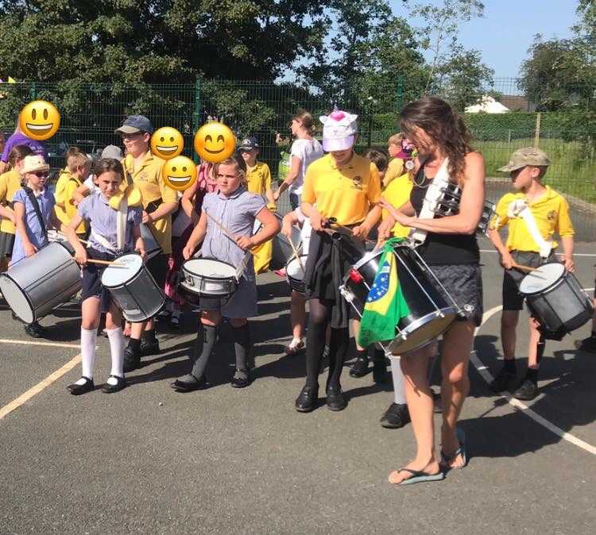

**Class 3 Solar Farm Trip**

This week also saw Class 3 out on a trip learning all about solar power, and how the farm works, they also focused on the biodiversity on the site. Children had binoculars to use with pooters and magnifying glasses for identifying bugs.

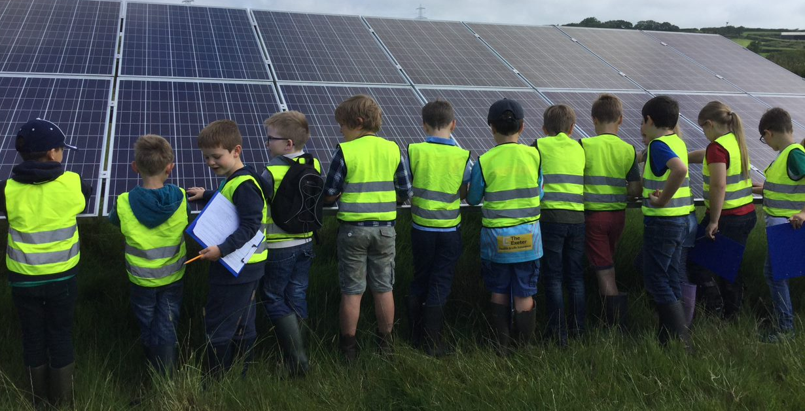 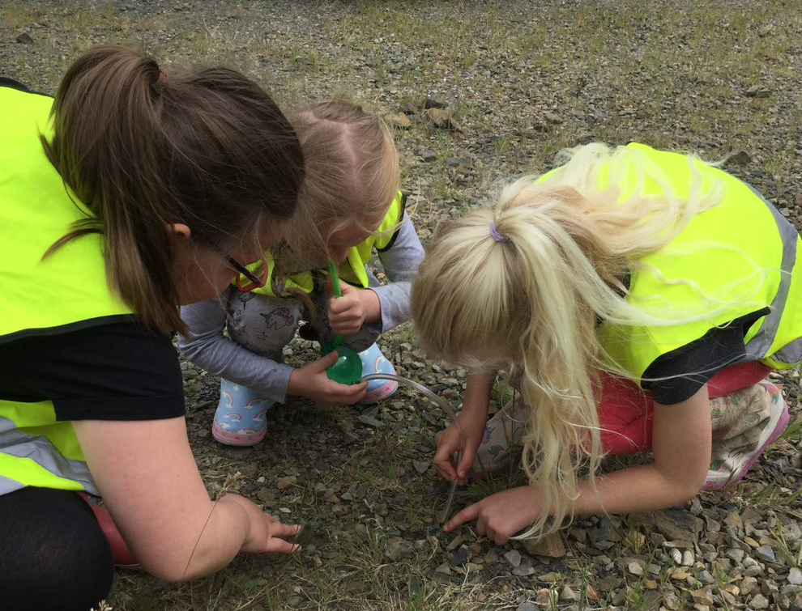

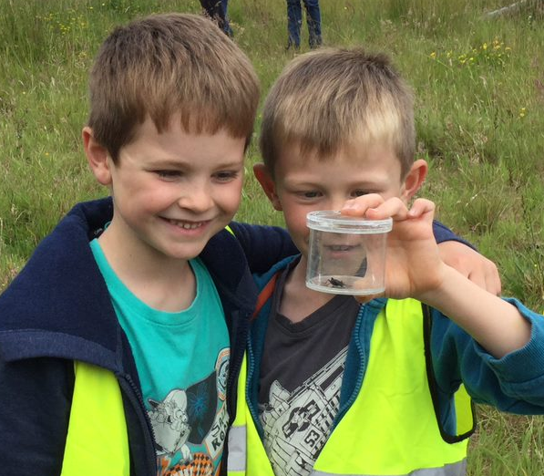

And final trip of the week was had by Class 1 & 2 who visited Newquay Zoo!

We can report that the children had a marvellous time at Newquay Zoo. All children behaved very well and were a credit to Warbstow Primary Academy. Everybody had the opportunity to handle some animals- from a cockroach to a snake! Spot the cheeky monkeys!

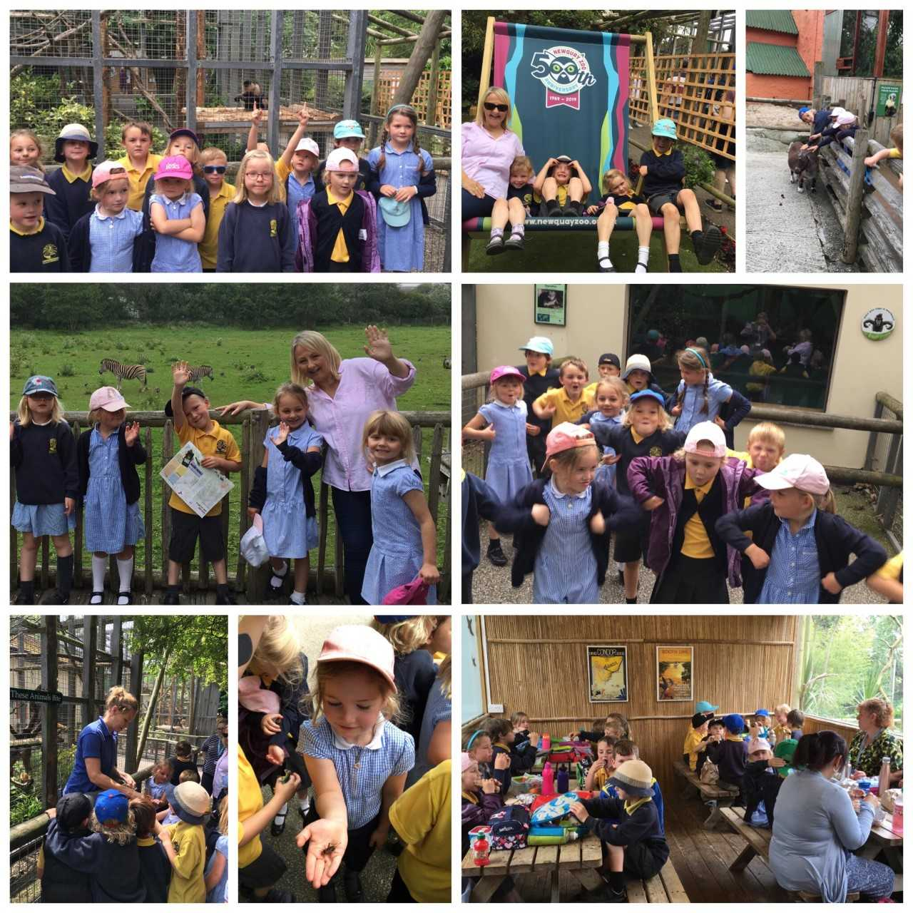

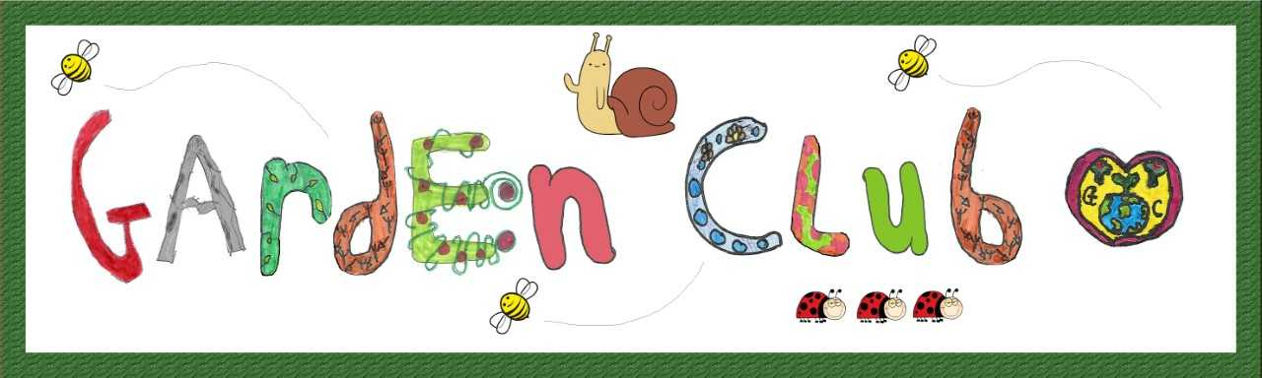

What a lovely sunny week! Today Garden Club and the Busy Bees finished our Bug Hotels and did a Bug Hunt to see who else lives on our field. The children found all sorts of insects including a lot of woodlouse!

The Bug Hotels are now fully finished to accommodate different insects on each layer including Spiders and Beetles, Snails, Solitary Bees, Ladybirds and Woodlouse.

The top layer is planted which we think makes them look great.

These places provide a warm sheltered habitat to either lay eggs or over winter.

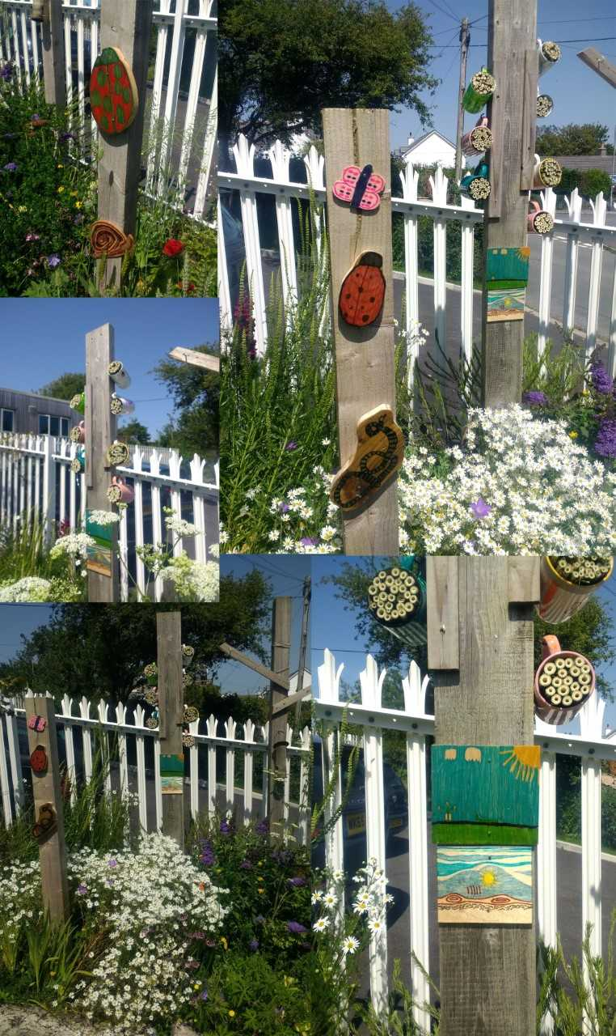 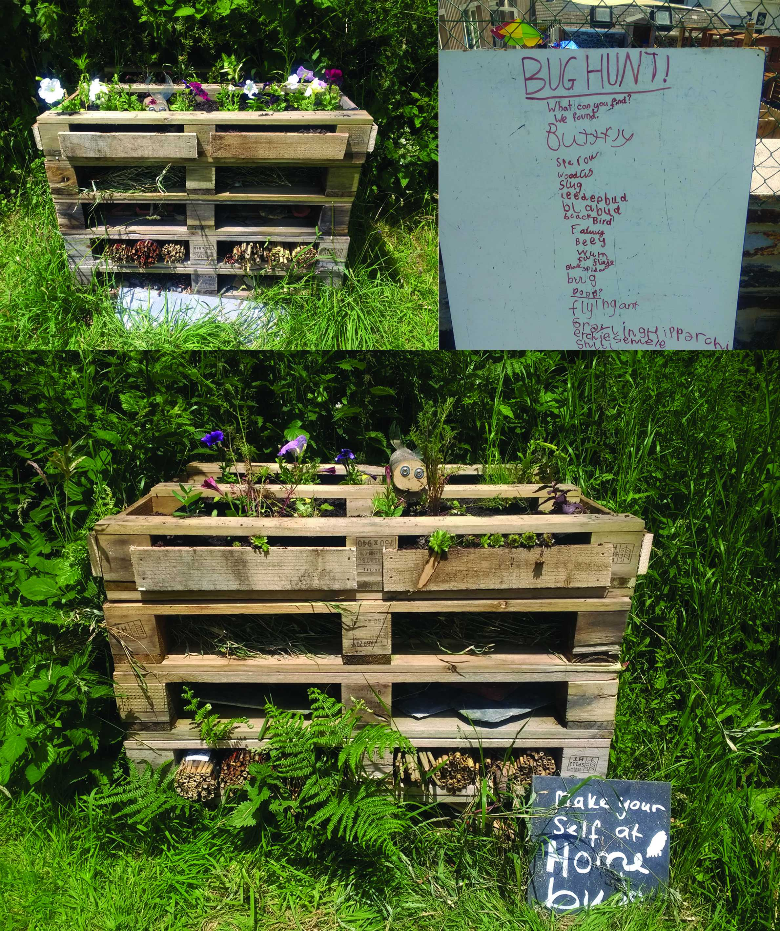

In the front garden there are a few craft projects we have finished and put up in the wildlife area.

Thank you to all my little helpers after school on Wednesday to pick the Blackcurrants. Although quite a few didn't make the bowl we still managed to harvest 1.8kg of fruit!

Don't forget to enter the Photo Competition this month. June is full of flowers and wildlife and we look forward to seeing what you have captured. Here are May's entries.

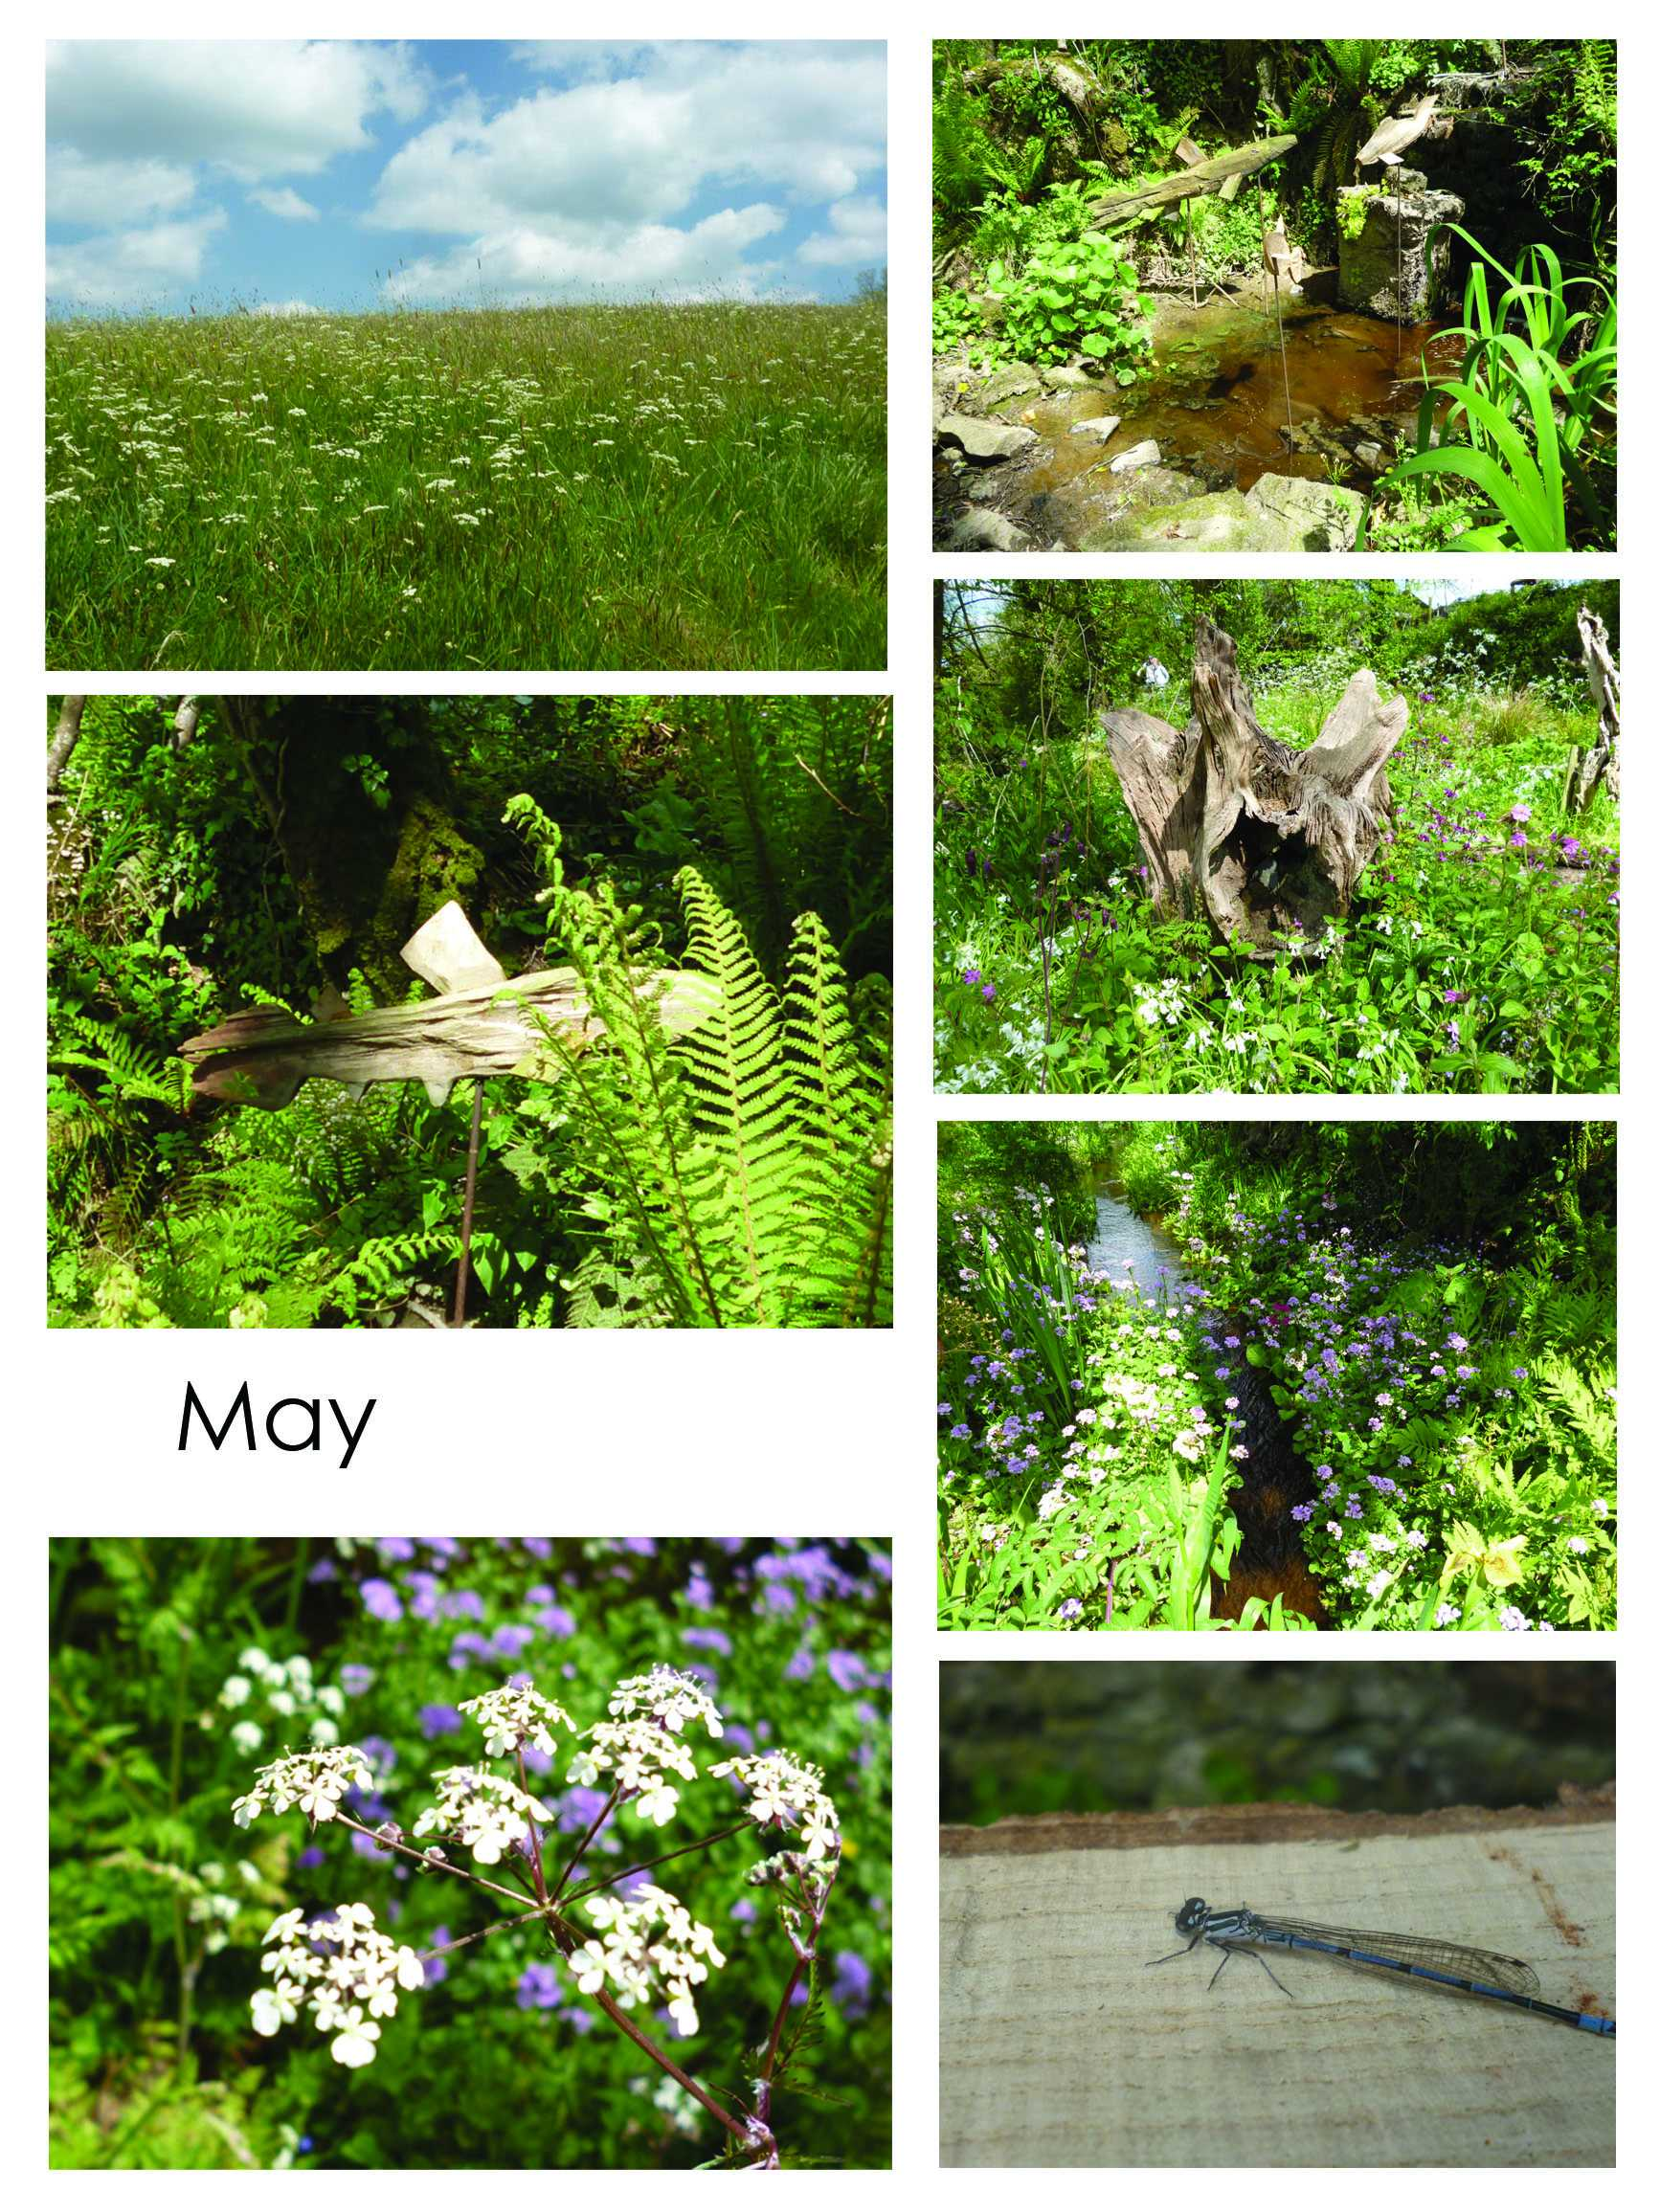

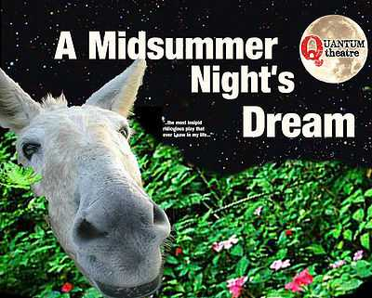

End the week in style – with some culture in the great outdoors!

Professional Open-Air Theatre returns to North Cornwall for one night only - in the grounds of the oldest building in Bude!

Quantum Theatre present

‘A Midsummer Night’s Dream’ by William Shakespeare

at Ebbingford Manor,Vicarage Road, Bude EX23 8LN

Friday 5 July 2019 at 6.30pm

With a quarrel raging between Oberon, King of the fairies and his Queen, Titania four young lovers become entangled in their magical affray and soon no mortals are safe in those bewitched and bewitching woods outside Athens. Quantum Theatre presents Shakespeare's most enduringly popular play of love and intrigue, magic and celebration, set on that most dangerous of nights, when fairies are abroad and nothing is as it seems...

Suitable for all the family

Tickets: £12 Full / £10 per person for Families (parent/s with child/children under 18yrs)

The play lasts approx 2 hours including an interval and is suitable for all ages.

Bring low back seating or blankets, suncream, picnics

Tea/coffee/refreshments available – proceeds to Friends of Bude Sea Pool

Raffle for Connect Bude (campaigning to reconnect Bude & Holsworthy to the National Railway Network initially via Okehampton) (To join Connect Bude please visit the website: http://www.connectbude.uk/ )

Tickets available now from:

Spencer Thorn Bookshop, Bude

Ark Angel Christian Bookshop, Bude

Seventh Wave Gallery, Bude

or via wegottickets https://www.wegottickets.com/event/475593

or on the door

This event is a B.O.A.T Show (Bude Open-Air Theatre) and is being promoted by Bude Youth Theatre.

Any proceeds will support free places in Bude Youth Theatre for those in hardship.

**Working Hard**

Freddie T

Lauren

Cory

Billy

**Working Hard**

Ollie W

Yasmin

Bertie

Warbstow Wonders

To share our children’s achievements we are going to publish the names of pupils receiving special certificates. This week congratulations go to: