Date: 11/06/2018 | Monday | Tuesday | Wednesday | Thursday | Friday
Large group activity | Making key-rings and cards | Making key-rings and cards | Making key-rings and cards | Woods with Reception  Making crowns | Our initial sounds – exploring sounds and letters of our names
Characteristics of learning | Playing and Exploring  Active Learning  Creating and thinking critically | Playing and Exploring  Active Learning  Creating and thinking critically | Playing and Exploring  Active Learning  Creating and thinking critically | Playing and Exploring  Active Learning  Creating and thinking critically | Playing and Exploring  Active Learning  Creating and Thinking critically
Areas of L and D | PSED PD CL L M UW EAD | PSED PD CL L M UW EAD | PSED PD CL L M UW EAD | PSED PD CL L M UW EAD | PSED PD CL L M UW EAD
Focus for learning | CL: Listening & attention – Is able to follow directions. 30-50 months | PD: Moving & Handling – Can copy some letters from their name. 30-50 months | UW: People & communities – Knows some of the things that makes them unique, and can talk about some of the similarities and differences in relations to friends and family. 30-50 months | UW: The world – Can talk about some of the things they have observed such as plants, animals, natural and found objects. 30-50 months | L: Reading – Hears and says the initial sound in a word. 40-60 months
Small group focused activity | Building with Jelly bricks | Friendship song - Cbeebies | Making instruments | Messy mud recipe | Ready steady build
Targeted children | Group 1: RW, JB, AC, PW, LB  Group 2: EW, BW, IF | LB, RW, JK, WB, LR, JB | RW, BW, EW, LR, BB | JB, WB, LR, RW, JK, YW, AC, SSH | PW, YW, JK, RW, LR
Areas of L and D | PSED PD CL L M UW EAD | PSED PD CL L M UW EAD | PSED PD CL L M UW EAD | PSED PD CL L M UW EAD | PSED PD CL L M UW EAD
Focus for learning | EAD: Exploring media & materials – Beginning to construct, stacking blocks vertically and horizontally, making enclosures and creating space. 30-50 months | PSED: Making relationships – Demonstrates friendly behaviour, initiating conversations and forming good relationships with peers and familiar adults. | Uses available resources to create probs. 30-50 months | EAD: Using media and materials – Beginning to be interested in and describe the texture of things. 30-50 months | CL: Listening and attention – Focusing attention. 30-50 months
Small group focused activity | I Spy | Den building | Mash potato sculptures | Chalk and water painting numbers | Washing babies
Targeted children | SSl, LB, AC, JB, BB | PW, SSl, SSh, YW, EW, TW, | PW, AC, SSh, LB, LR, YW, RW | YW, RW, LR, JK, AC, SSh | SSl, BB, FT, EW, IF
Areas of L and D | PSED PD CL L M UW EAD | PSED PD CL L M UW EAD | PSED PD CL L M UW EAD | PSED PD CL L M UW EAD | PSED PD CL L M UW EAD
Focus for learning | L: Reading – Show awareness of rhythm and alliteration. 30-50 months | PSED: Making relationships – Can play in groups, extending and elaborating on play ideas. 30-50 months | PD: Moving and Handling – Uses one-handed tools and equipment. 30-50 months | M: Numbers – Show and interest in numerals. 30-50 months | EAD: Being imaginative – Engages in imaginative role-play. 30-50 months

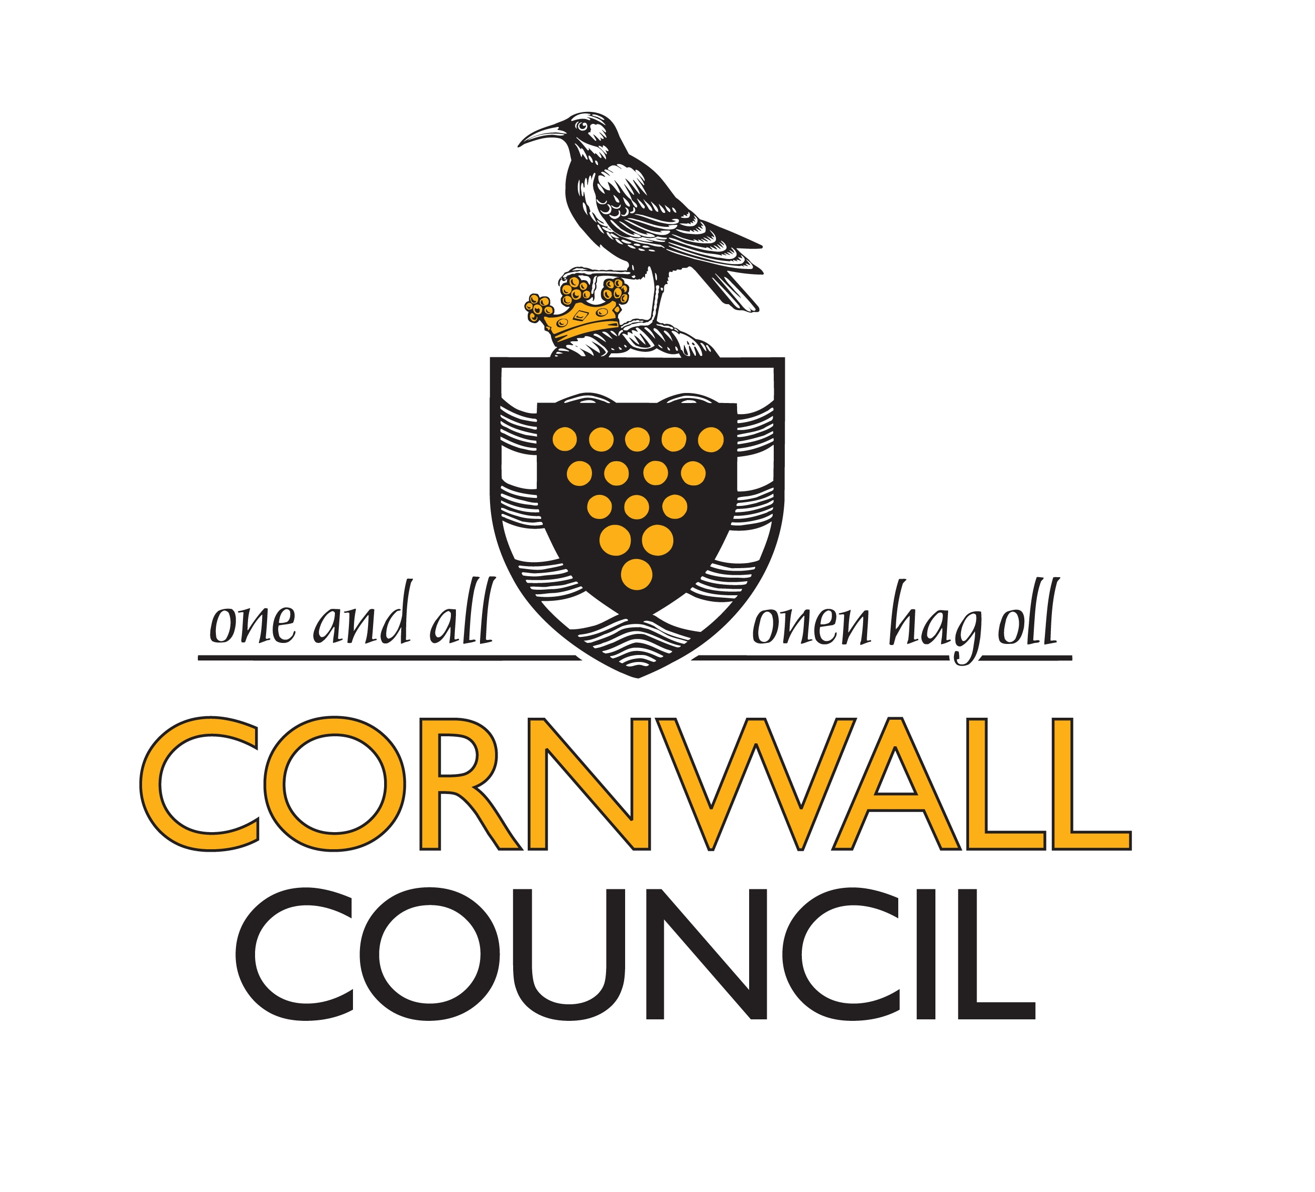 WEEKLY PLANNING ADULT-LED ACTIVITIES INSIDE/OUTSIDE
Green – Activities planned in response to children’s interests and next steps Blue – Activities to ensure a balance across the curriculum

CHARACTERISTICS OF LEARNING
Playing and Exploring  - Finding out and exploring  - Playing with what they know  - Being willing to’ have a go’ | Active learning  - Being involved and concentrating  - Keeping trying  - Enjoying achieving what they set out to do | Creating and thinking critically  - Having their own ideas  - Making links  - Choosing ways to do things

WEEKLY PLANNING CHILD-INITIATED ACTIVITIES INSIDE AND OUTSIDE/CONTINUOUS PROVISION
Green – Activities planned in response to children’s interests Blue – Activities to ensure a balance across the curriculum

Week beginning: 04/06/2018
Sand |  | Water |  | Malleable/sensory/ investigation
Inside  Mini beasts, sticks, scoops and bowls. | Outside  Sand runs using pipes and guttering | Inside | Outside  Washing babies | Inside  Mash Potato structures | Outside
Mathematics |  | Role play |  | Letter and sounds
Inside  Sizes | Outside  Chalk and water number painting | Inside  Construction site | Outside  Den building | Inside  I spy game | Outside
Listening/music |  | ICT |  | Designing and Making Area
Inside  Painting with sounds | Outside  Music tray | Inside | Outside | Inside  Making key rings and cards  Making instruments | Outside
Small world |  | Construction |  | Puzzles and games
Inside  Cars in tuff spot | Outside  Toys cars – car wash | Inside  Building homes – bungalows, houses, flats, terrace, semi-detached. | Outside  Stick tents | Inside  I Spy | Outside
Finger gym |  | Mark-making |  | Physical
Inside  Stick wrapping | Outside  Whisking bubbles | Inside | Outside | Inside | Outside

Playing and Exploring  - Finding out and exploring  - Playing with what they know  - Being willing to’ have a go’ | Active learning  - Being involved and concentrating  - Keeping trying  - Enjoying achieving what they set out to do | Creating and thinking critically  - Having their own ideas  - Making links  - Choosing ways to do things

